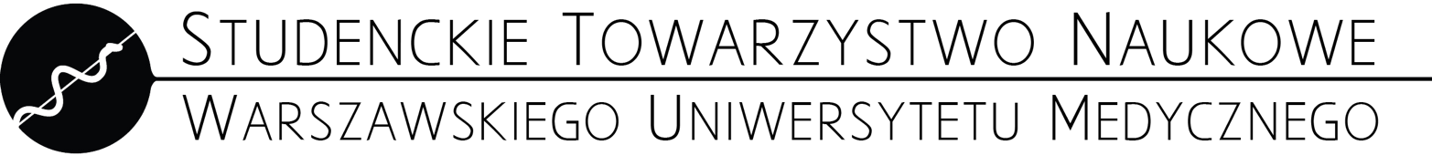
APPLICATION FORM FOR THE GOLD BADGE OF THE
STUDENTS' SCIENTIFIC ASSOCIATION OF
MEDICAL UNIVERSITY OF WARSAW
Published 2nd June 2024

First and last name of the graduate
Graduate's graduation year*
Degree obtained
Faculty graduated by the graduate
Title received as a result of graduation
Graduate's album number
Name of APPLICANT
APPLICANT'S contact number
E-mail address of APPLICANT
* The form can only be submitted prior to the Faculty Diplatorium, during which the graduate in question will receive his or her diploma according to the schedule listed on the STN website.

List of copies of documents attached:

a) The author of the presented research and b) the presenting award winner at the work presentation site (scored together)
 | Title | Name of the event | Date of the event | Country | Form of presentation | Award won | Presenter | Points  according to the Regulations
1.
2.
3.
4.
5.
...
Confirmed by a certificate of participation and any award certificate.

c) Publications

 | Journal title | Title | Pages/  number/year | Authors in order | Corresponding author  (when not stated, 1st author of publication) | Points as of MNiSW list | Points according to the Regulations
1.
2.
3.
4.
5.
...
Confirmed by a certificate of acceptance, a scan of the publication or information from the portal publikacje.wum.edu.pl, allowing verification of all elements.

c) Chapter of a book or monograph that has an ISBN number

 | Book Title | Title of chapter | Pages/  number/year | Authors in order | ISBN number/year of publication
1.
2.

d) Grants

 | Title | Grant type | Leader | Participants | Years of realization | Other information
1.
2.

e) Membership in the conference organizing committee (confirmed by a certificate or scan from the conference book)

f) Opinion of the SKN Supervisor or the Head of the WUM unit on the previous activity in the SKN structures

g) Membership in the top management of student organizations (confirmed by a verifiable document)
SUM OF POINTS (counted by the applicant).

Date and signature of Board Member  (person accepting the application) | Signature of Applicant
…............................................................. | ….............................................................

